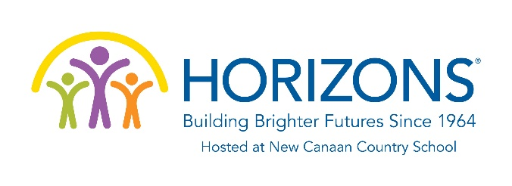

Class Representative Job Description

As a Horizons at NCCS Alumni Association Class Representative, you will embody all that Horizons at NCCS values and support the transformative opportunities provided through our program. You will uphold and implement the vision and mission of the program. A Horizons at NCCS Alumni Association Class Representative will:
- Connect the alumni of the Horizons at NCCS program from your given cohort, with the Association and all relevant programming, opportunities and information. This includes but is not limited to:
  - Communication of current program support, volunteer opportunities and/or other information noted as relevant, meaningful and in line with the associations goals and objectives. This is to be coordinated with input from the office staff and VISTA member.
  - Promotion of special events, reunions, programming, fundraisers, etc.
  - Lead engagement among cohort members on all social media platforms.
  - Gather, track and share updated contact information with Horizons at NCCS.

